**23 Dec2019:**

Oracle download:

<https://www.oracle.com/database/technologies/xe-prior-releases.html>

<https://www.oracle.com/database/technologies/xe-prior-releases.html>

<https://www.oracle.com/technetwork/developer-tools/sql-developer/downloads/index.html>

alter user HR identified by password account unlock;

select <column_nm>,<col_nm>.... FROM <user>.<table_nm>;

select * from hr.departments;

select department_name ,department_id from hr.departments;

select * from hr.employees;

select * from GCBC_HR.SALESPERSON_STORES;

**24 Dec2019:**

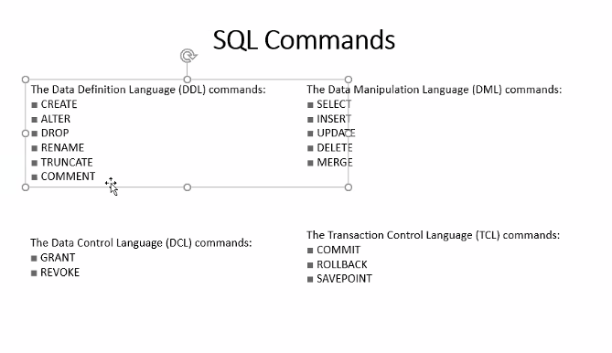

**select employee_id,department_id,first_name,last_name,salary from HR.employees where salary > 15000;**

**select employee_id,department_id,first_name,last_name,salary from HR.employees where salary > 15000;**

**select employee_id,department_id,first_name,last_name,salary from HR.employees where salary > 15000 AND employee_id =101 AND**

**department_id =90;**

**CREATE TABLE HR.CUSTOMERS**

**(**

**CUST_ID NUMBER NOT NULL,**

**CUST_NAME VARCHAR2 (20) NOT NULL,**

**AGE NUMBER NOT NULL,**

**ADDRESS CHAR (25) ,**

**SALARY NUMBER (18, 2),**

**PRIMARY KEY (CUST_ID )**

**);**

**alter table hr.customer add mobile_number number(10);**

**insert into hr.customer (cust_id,cust_name,age,address,salary,mobile_number) values (1,'Akriti', 20,'Bangalore',40000,999999999);insert into hr.customer values (2,'Shweta', 20,'Hyderabad',41000,999999999);select * from HR.CUSTOMER;INSERT INTO TABLE_NAME (column1, column2 …) VALUES (value1, value2…);insert into hr.customer (cust_id,cust_name,age,address,salary,mobile_number) values (1,'Akriti', 20,'Bangalore',40000,999999999);insert into hr.customer values (2,'Shweta', 20,'Hyderabad',41000,999999999);**

**commit;**

<https://drive.google.com/drive/folders/1H80mxUih3Iuy_KeTfAbv4DkspL2_IDmj>

select department_id as department_identification,department_name,manager_id,location_id from hr.Departments;

select E1.employee_id ,E.department_id,E1.first_name from hr.employees E INNER JOIN hr.employees1 E1

ON E.department_id = E1.department_id where E1.department_id = 50;

insert into employees1 select * from employees where department_id < = 70;

create table employees1 as select * from employees where 1=2;

select * from hr.employees E

FULL OUTER JOIN hr.employees1 E1

ON E.department_id = E1.department_id order by E.department_id asc;

select E.employee_id,E.first_name,E.EMAIL,E.department_id from hr.employees E LEFT OUTER JOIN hr.employees1 E1

ON E.department_id = E1.department_id order by E.department_id desc;

select E.employee_id,E.first_name,E.EMAIL,E.department_id from hr.employees E RIGHT OUTER JOIN hr.employees1 E1

ON E.department_id = E1.department_id order by E.department_id desc;

select count(1) from employees where department_id =50;

select distinct(manager_id) from employees;

select * from employees where employee_id > 50 AND salary > 5000 AND job_id = 'IT_PROG';

select * from employees where employee_id > 50 AND salary > 5000 AND job_id = 'IT_PROG';

select * from employees where salary between 3000 and 6000;

select * from employees where job_id IN ( 'IT_PROG' ,'SH_CLERK');

select * from employees where employee_id > 50 AND salary > 5000 AND job_id = 'IT_PROG';select * from employees where salary between 3000 and 6000;select * from employees where job_id IN ( 'IT_PROG' ,'SH_CLERK');select * from employees where job_id = 'IT_PROG' OR job_id = 'Learnbay';

From Learnbay Python to Everyone: 09:27 AM

select count(1) from employees where department_id =50;

select distinct(manager_id) from employees;

From Learnbay Python to Everyone: 09:39 AM

select * from employees where employee_id > 50 AND salary > 5000 AND job_id = 'IT_PROG';select * from employees where salary between 3000 and 6000;select * from employees where job_id IN ( 'IT_PROG' ,'SH_CLERK');select * from employees where job_id = 'IT_PROG' OR job_id = 'Learnbay';

select employee_id,first_name from employees where first_name like '%is%';